**Embedd pig scripts inside a java program**

**Step1:Embedd the pig script in java By using the Pig Server class**

**Step2:Call the runquerry Method which runs the querry**

**Step3:Register the querry by using pigServer.registerQuery**

**Step4:Include the necessary jars of pig library folder and Include the common library jar of Hadoop and add the necessary dependencies by converting it into a Maven Project**

**Step5:Use Properties class and set property method to set localhost Url**

**Input**

**Now I am Going to do a wordcount Program on the following file in HDFS**



**Code**

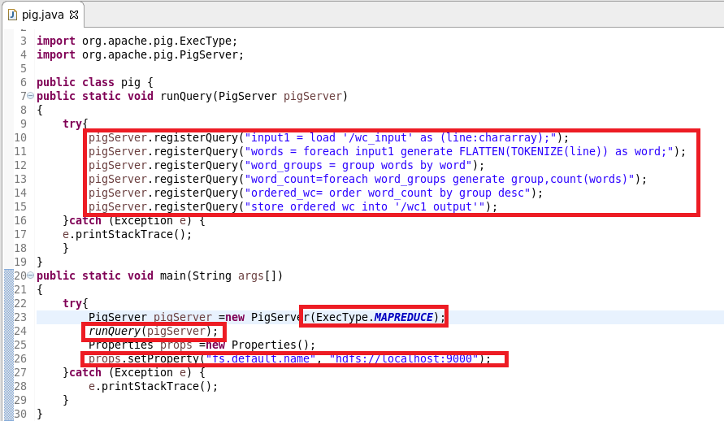

**Pom.xml file**

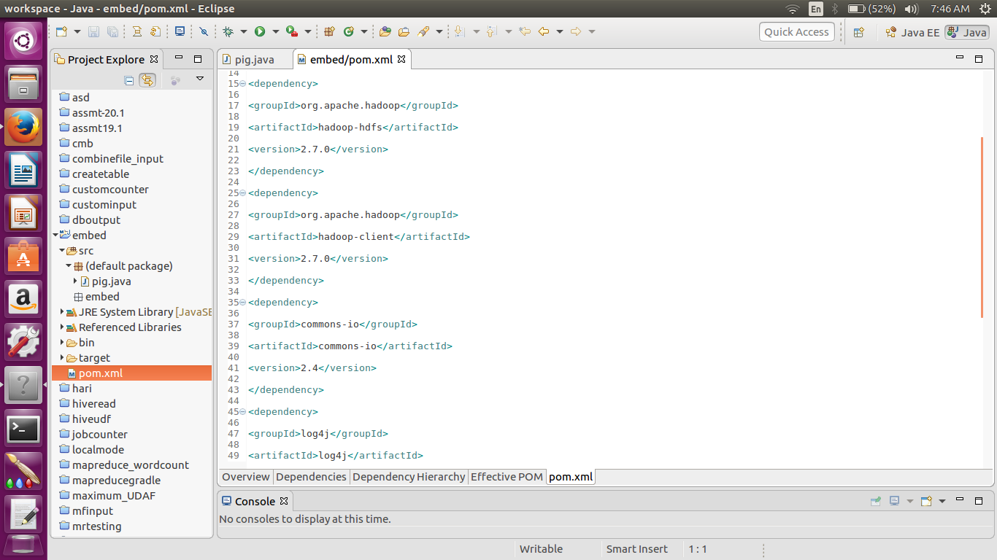

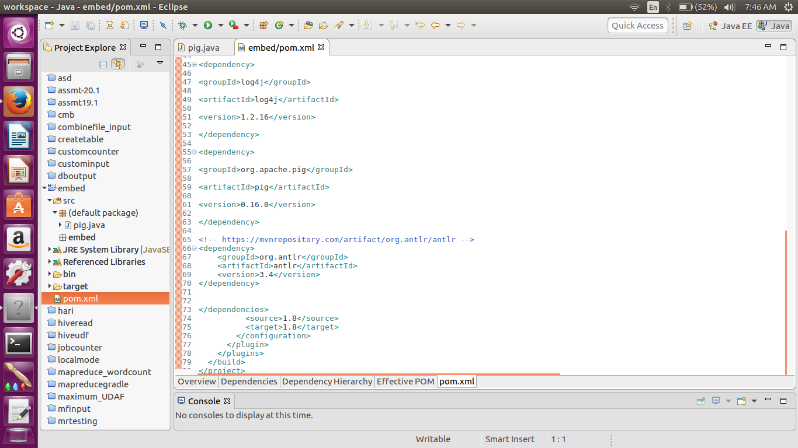

**Output Running on Console**

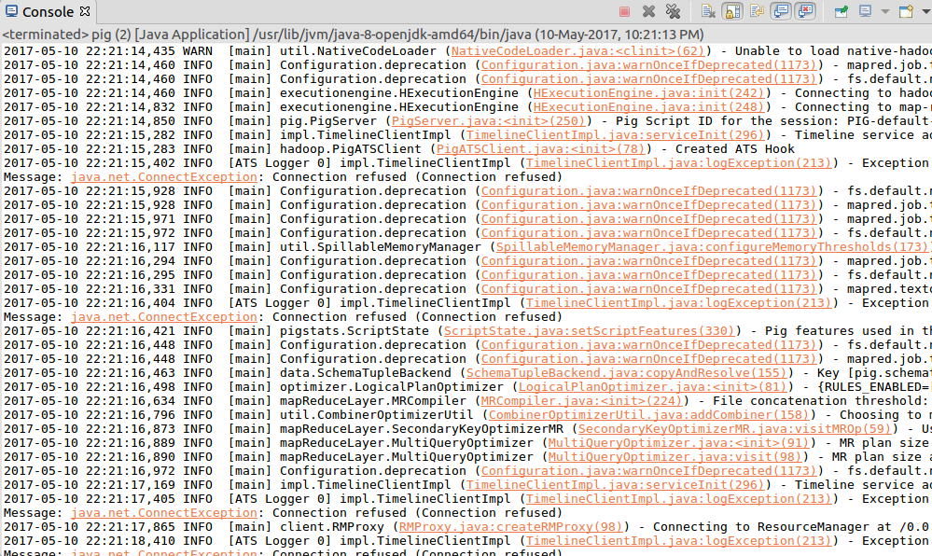

**Output successfully stored on /wc1_output**

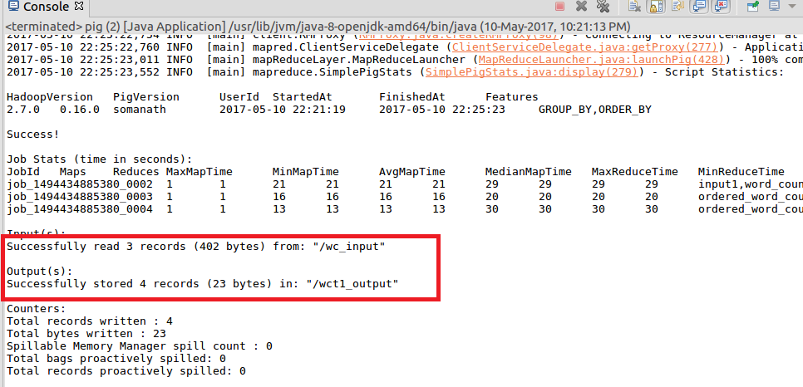

**Output**

**Output is successfully stored in /wc1_output**

